vDrive Sound Board Installation.

Version 1.0. 2021/10/7 S.R.Usher

The vDrive sound board has three connections to the vDrive board, two for power and one to control the sound, and two wires to go to the speaker.

A suitable speaker for the device is 8 ohms and a 20mm diameter speaker will fit at the back of the ZX Microdrive case.

The design utilises an ATTiny85 micro controller to play back a short digitised sound clip of an actual ZX Microdrive and so sounds reasonably accurate.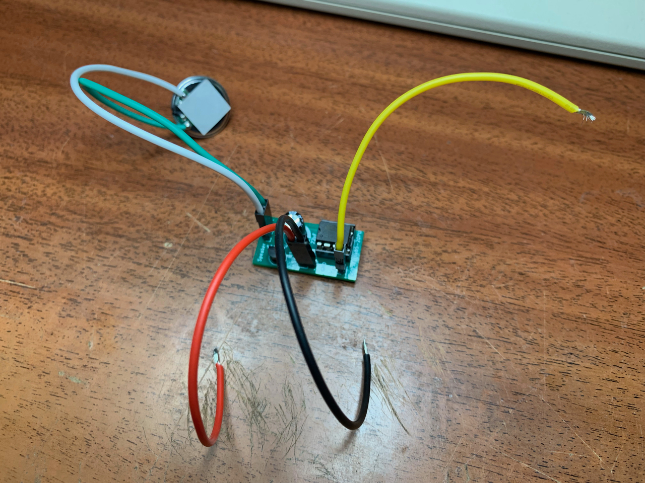

You can see here the five wires and a speaker connected to the board. In this case the wires are coded red and black for +5V and ground and yellow for the control wire.

First we will deal with the power. Locate the power regulator on the main circuit board behind the drive cage. Note the legs. The left-most, looking from the rear of the vDrive, is the +5 volt leg and the centre one is ground. The right one carries the +9 volt supply from the Interface 1 or QL so don’t connect any wires to that!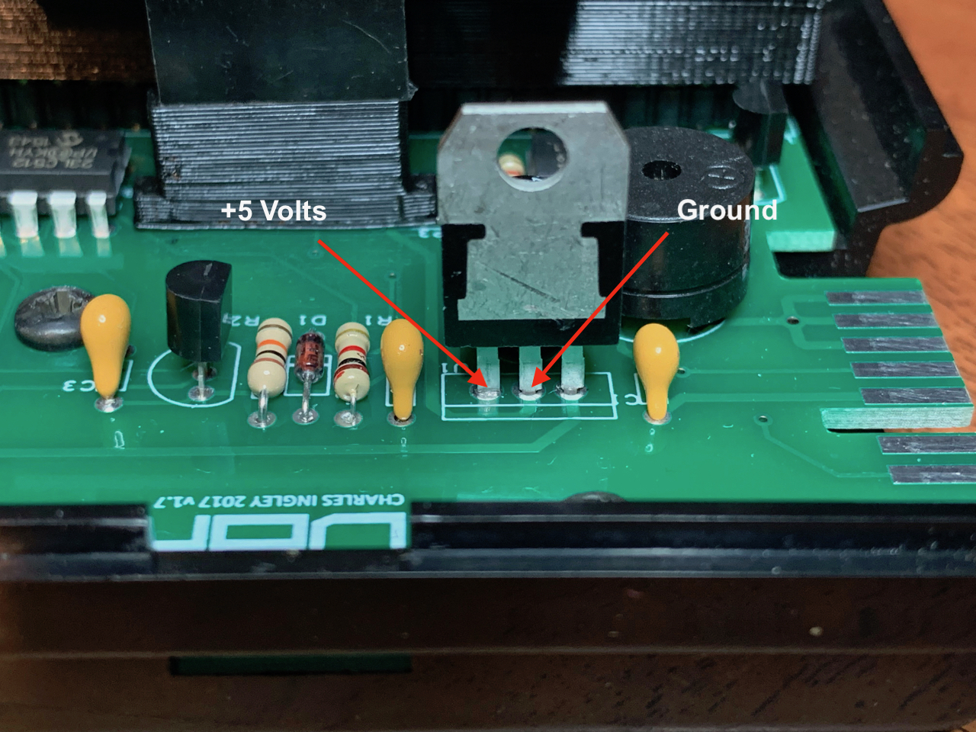

Add solder to the middle and left legs of the regulator and then carefully solder the red and black wires onto them, making sure not to bridge the two connections with too much solder.

The wires should now look like this:

Now we need to solder the control wire, yellow, to the leg of the resistor connected to the red coloured LED, as this is lit whenever the vDrive is reading data.

Locate the two resistors at the front of the drive, on the left as you look from the front.

The yellow wire needs to be connected to the right side of the rear resistor. Again, add some new sold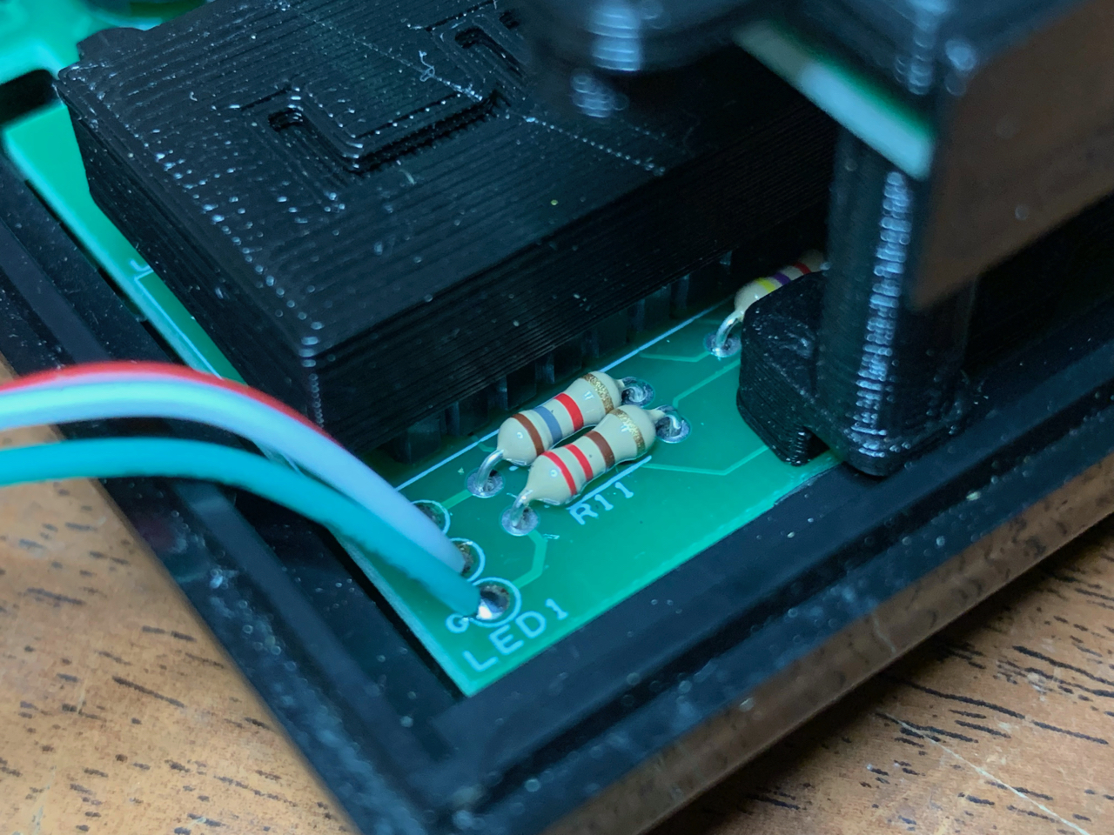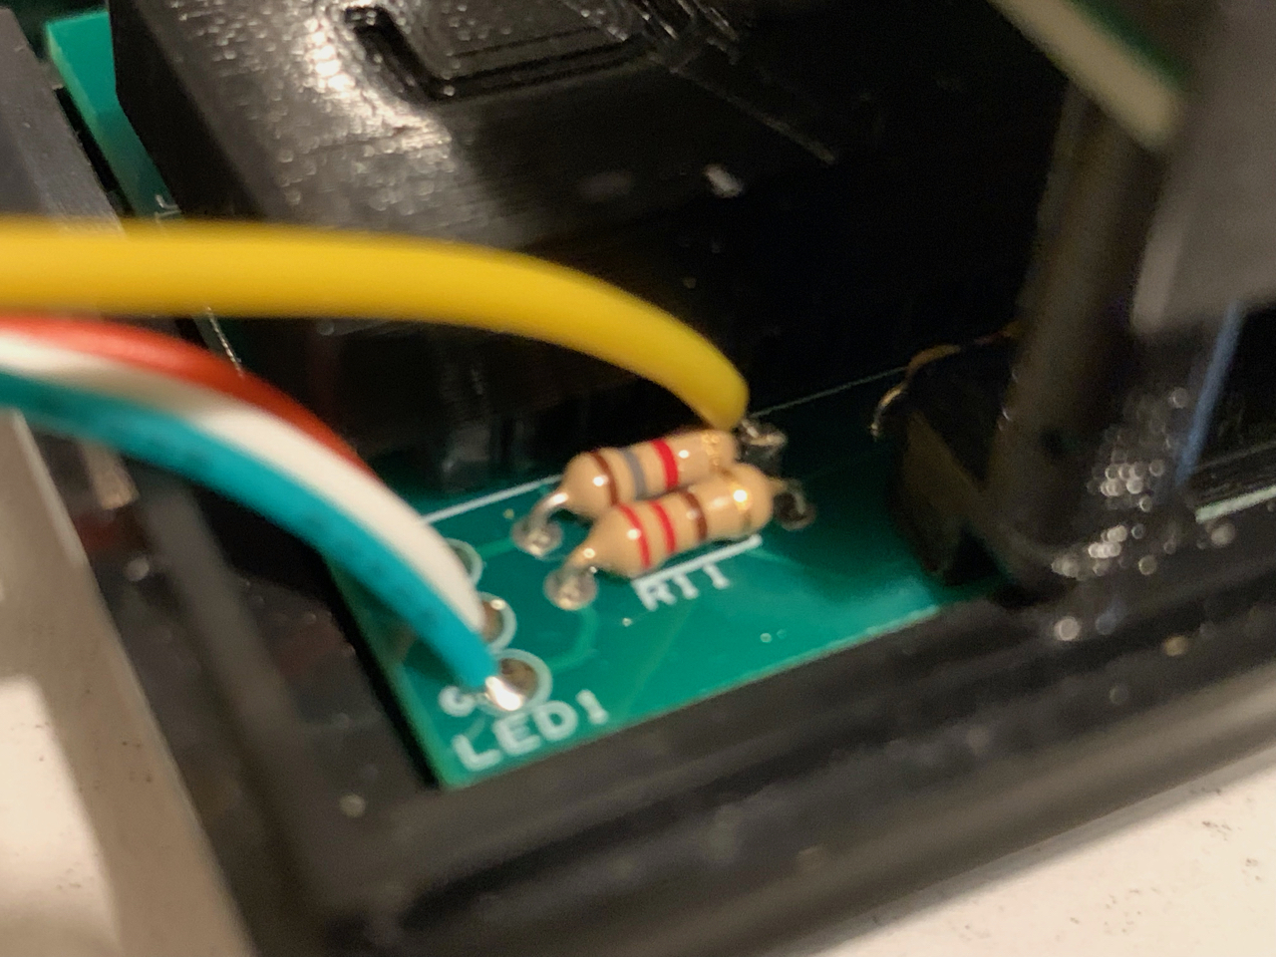er and then solder the yellow wire on:

The difficult bit is now complete. Attach the board to the top of the 3D printed vDrive cover which passes under the drive cage using double sided tape. The best sort is the type designed for use in cars which has a foam filler between the two sticky layers. The speaker wires should point to the rear of the drive.

The speaker can now be glued to the rear bulkhead of the ZX Microdrive case, reasonably high up. This is both a convenient position and allows the rear of the case to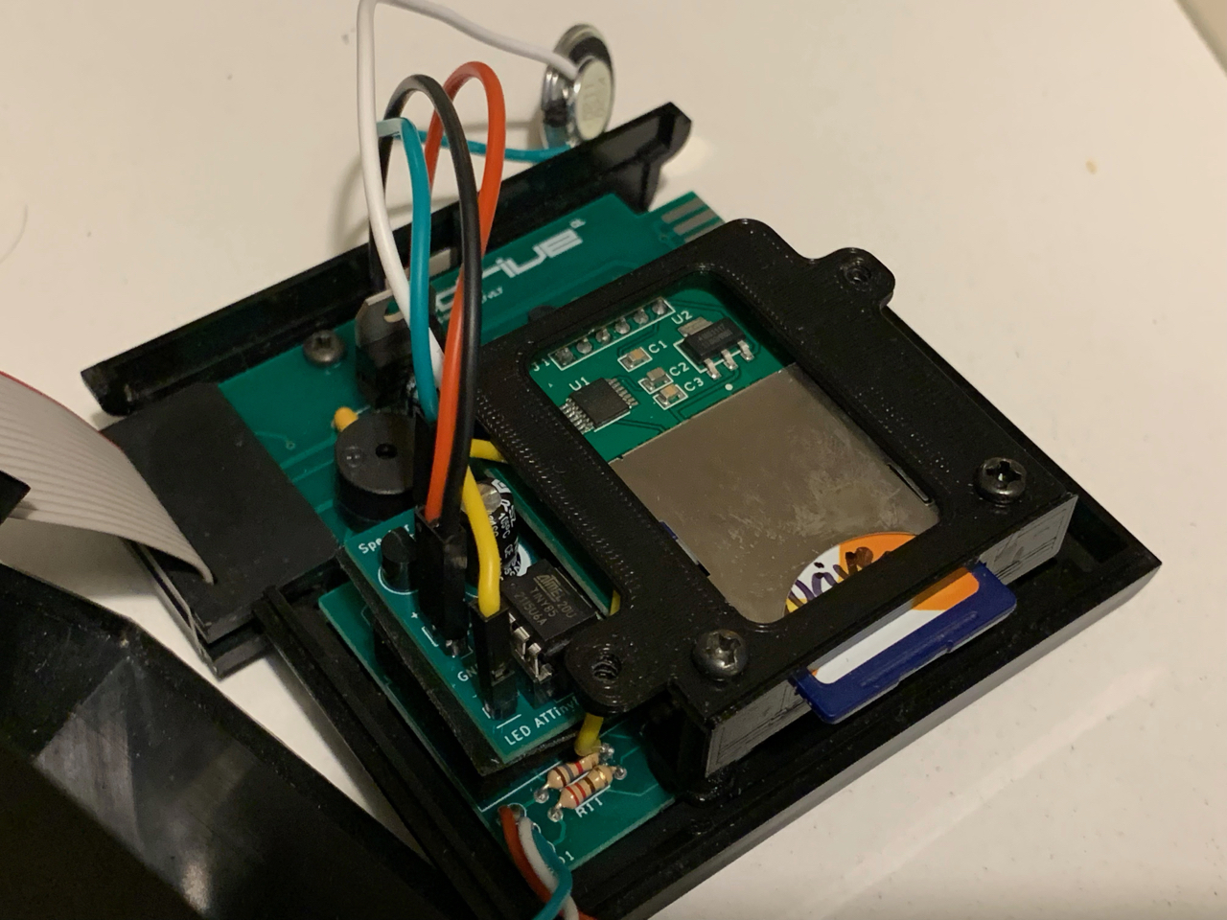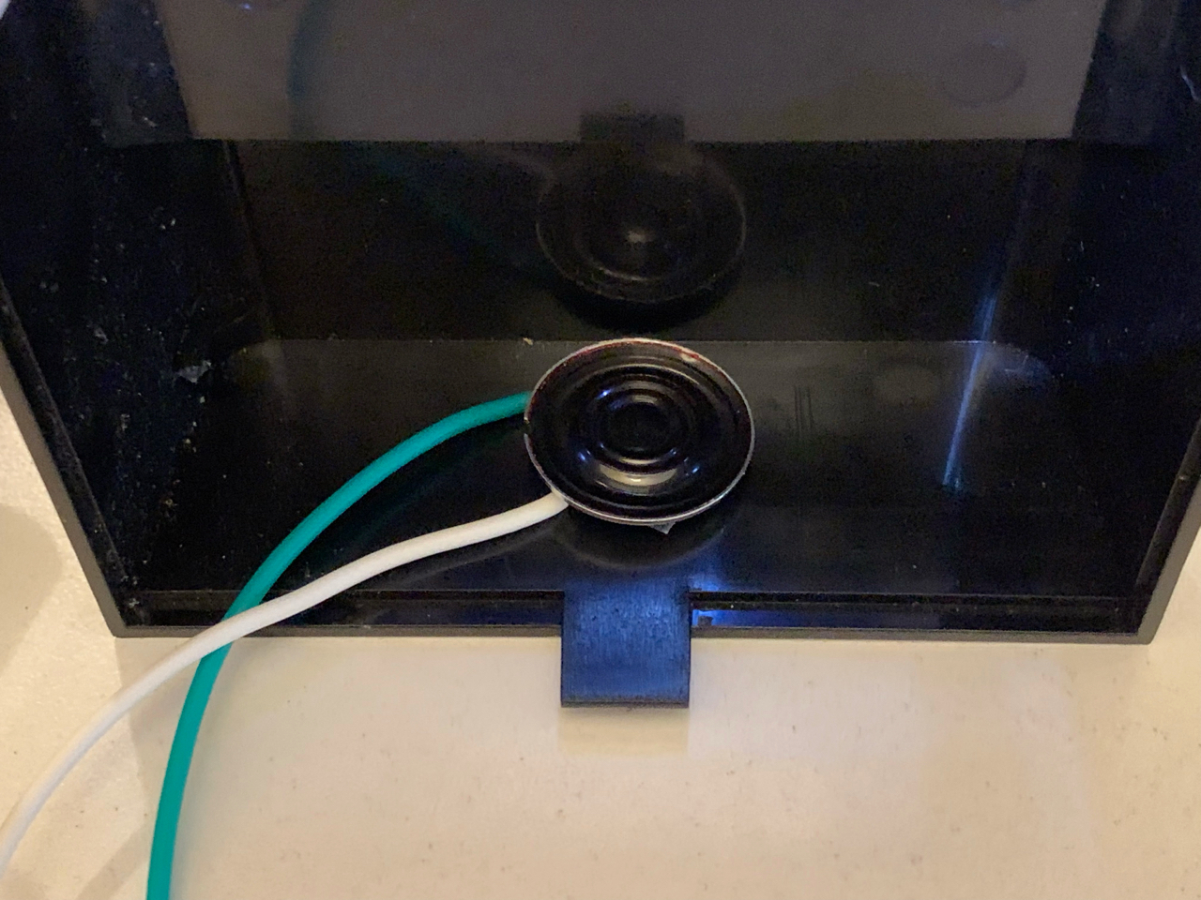 become a sounding board, amplifying the sound. The inside of the case will be a resonance chamber too.

Once this has been completed then you can reassemble the case.